**A step by step (screenshots) tutorial for upgrading R on Windows**

[R-statistics blog](https://www.r-statistics.com/)

Statistics with R, and open source stuff (software, data, community)

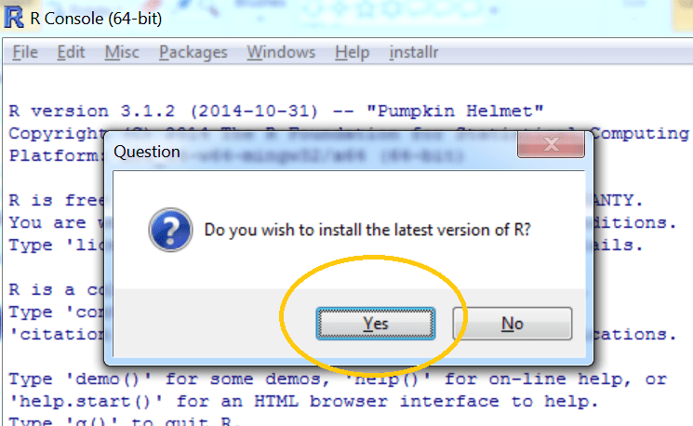

**tl;dr**

If you are running R on **Windows**you can easily upgrade to the latest version of R using [the installr package](https://cran.r-project.org/web/packages/installr/). Simply run the following code:

|  |
| --- |
| # installing/loading the latest installr package:  **install.packages**("installr"); **library**(installr) # install+load installr    updateR() # updating R. |

Running “updateR()” will detect if there is a new R version available, and if so it will download+install it (etc.). just press “next”, “OK”, and “Yes” on everything…

**A GUI interface to updating R on Windows**

Starting from installr version 0.15.0, the upgradingprocess can be done with a click-on-menus GUI interface. Here is how to use it.

**Step 1:** load installr

|  |
| --- |
| # installing/loading the latest installr package:  **install.packages**("installr") # install installr  **library**(installr) #load |

**Step 2:** pick “update R” from the new “installr” menu

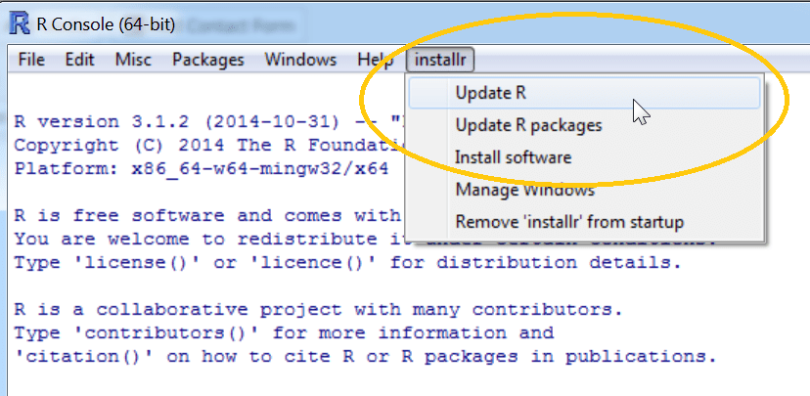

**Step 3:** installr will check and detect that there is a new version of R for you – click “OK”

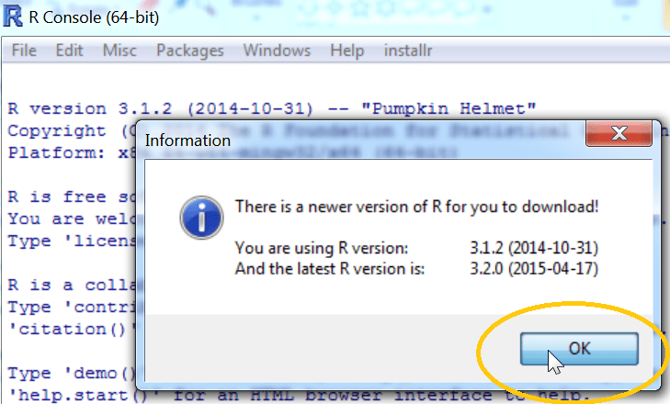

**Step 4:** if you wish to check the NEWS of the new R version – click “Yes” and a browser window will open up with this information

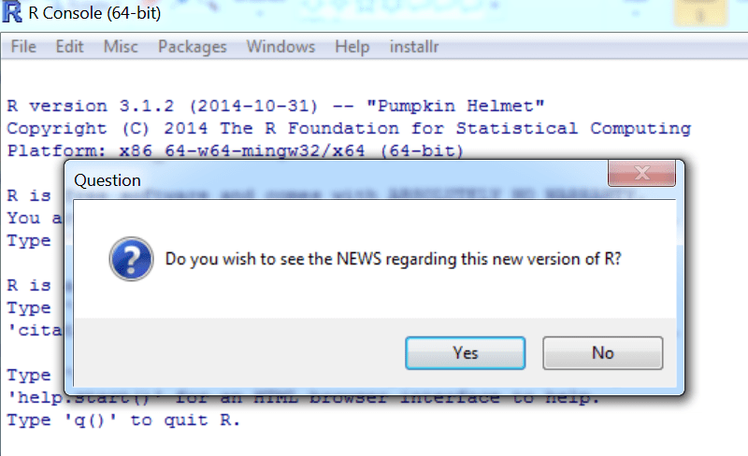

**Step 5:** if you want to download and install the latest R version, press “Yes”



**Step 6:** wait for R to download

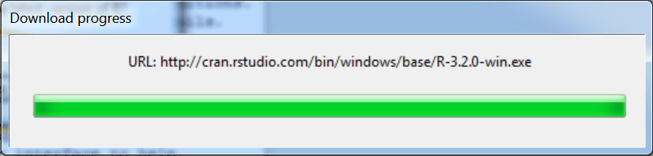

**Step 7:** press “next” in R’s installation wizard

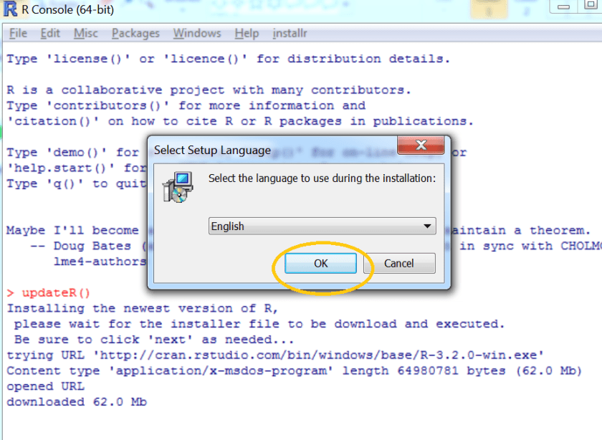

**Step 8:** wait R finishes to get installed

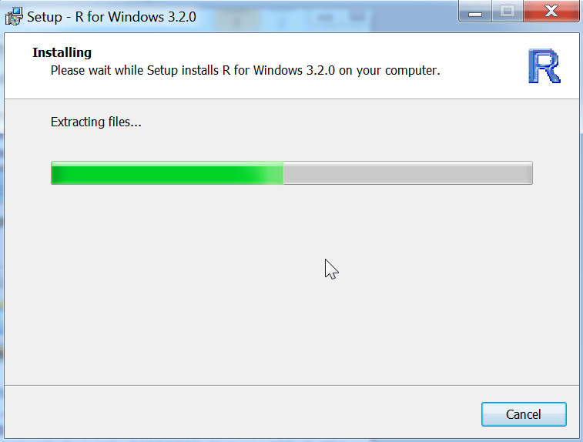

**Step 9:** Press “Yes” to copy your packages to the new R installation (press No, if you intend to use the “[global R library folder](https://www.r-statistics.com/2011/04/how-to-upgrade-r-on-windows-7/)” strategy)

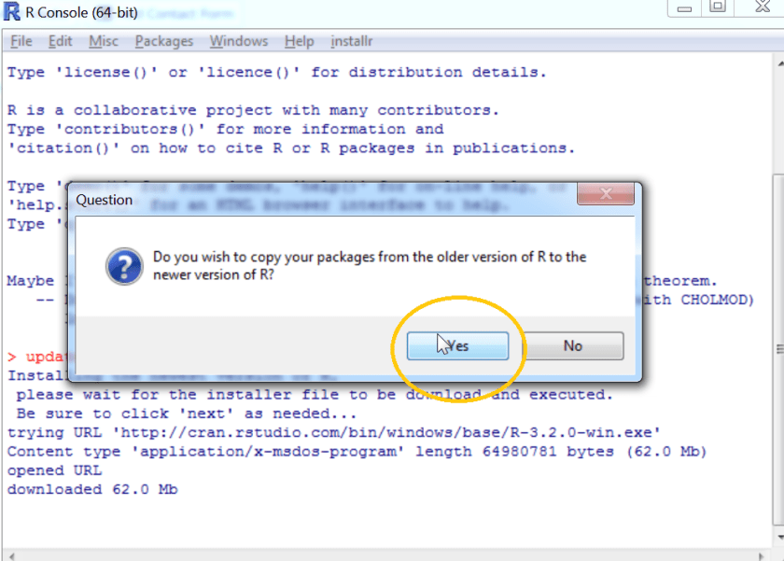

**Step 10:** to keep package in your old R folder, press “Yes” (this is safest)

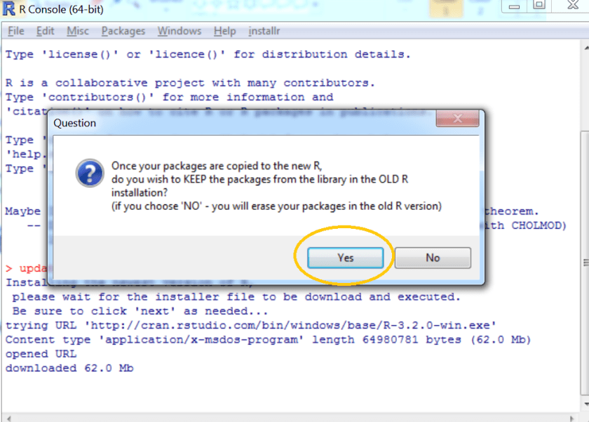

**Step 11:** wait while the packages get copied

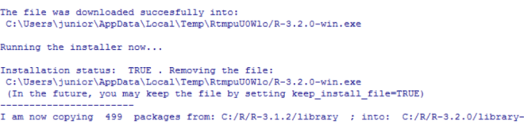

**Step 12:** you can also have Rprofile.site be copied automatically to the new location

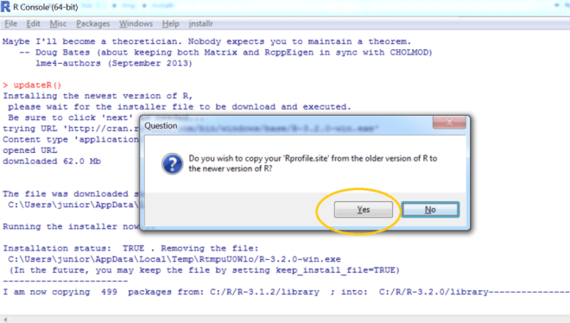

**Step 13:** you may press “Yes” to get update packages in the new R installation

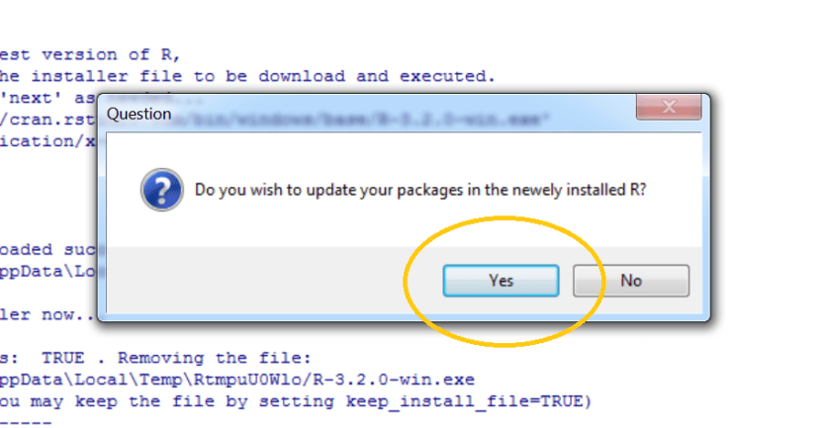

**Step 14:** if you have a firewall, R may ask to get access to the internet

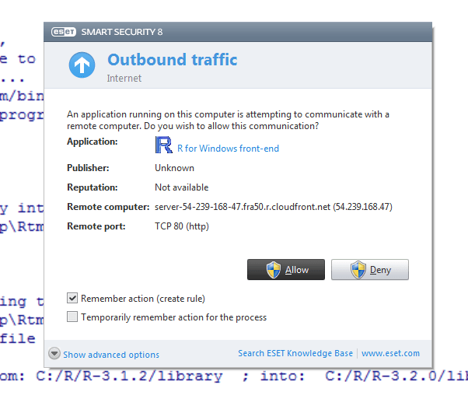

**Step 15:** while the packages are updated, you will need to wait. A hidden Rscript process will run in the background and update the packages

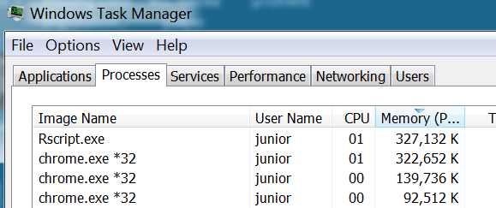

**Step 16:** once it is all done, you will be offered to quit R (sure, why not)

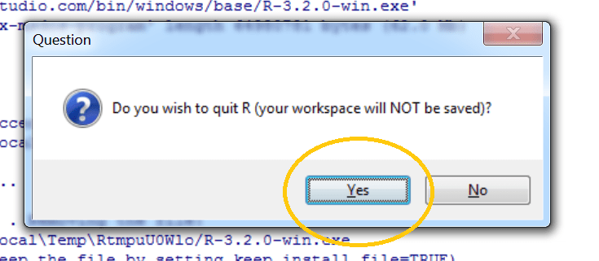

That’s it.

**Feedback**

I try to keep the installr package updated and useful, so if you have any suggestions or remarks on the package – you are invited to leave a comment below, or [report an issue on github](https://github.com/talgalili/installr/issues).

Author [Tal Galili](https://www.r-statistics.com/author/theshadow/)Posted on [June 15, 2015Categories](https://www.r-statistics.com/2015/06/a-step-by-step-screenshots-tutorial-for-upgrading-r-on-windows/)[R](https://www.r-statistics.com/category/r/), [R programming](https://www.r-statistics.com/category/r-programming/), [Reproducible Research](https://www.r-statistics.com/category/reproducible-research/)Tags [0.16.0](https://www.r-statistics.com/tag/0-16-0/), [installr](https://www.r-statistics.com/tag/installr/), [R](https://www.r-statistics.com/tag/r/)